**DEVELOP A MOBILE APPLICATION**

|  |  |
| --- | --- |
| **Team ID** | PNT2022TMID26330 |
| **Team Members** | Aparna K, Akshaya R, Harshini PR, Adithi R |
| **Project Name** | Smart farmer-IOT enabled smart farming application |

**Step 1:** Login to MIT App Inventor

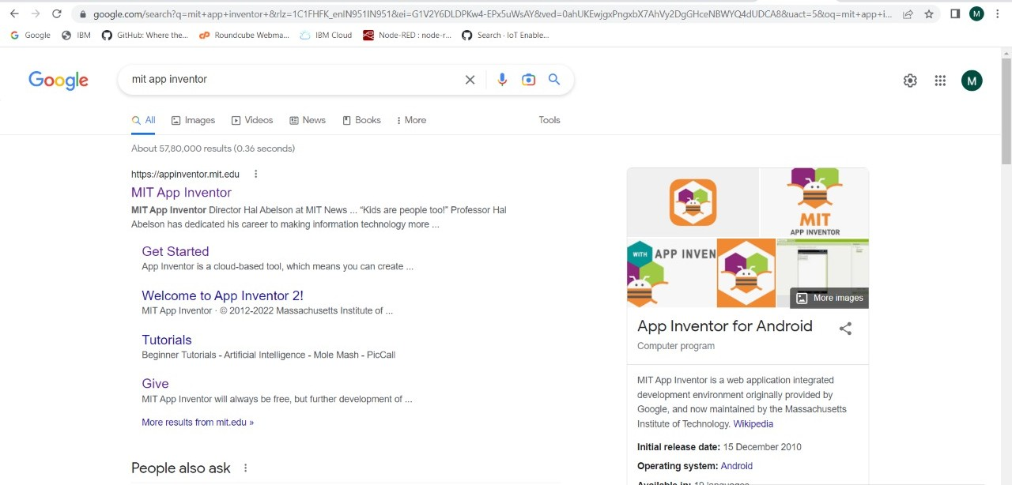

**Step 2:** Drop & place The Essential Features In The Front End Process

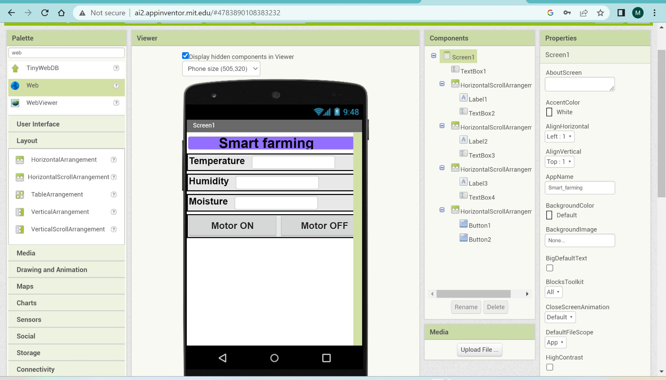

**Step 3:** Backend Block

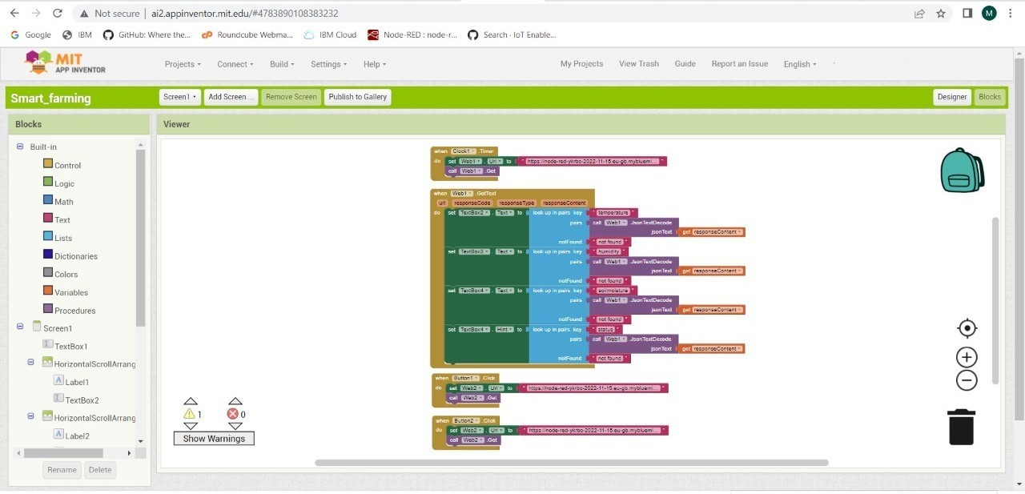

**Step 4**: Build the App & Install

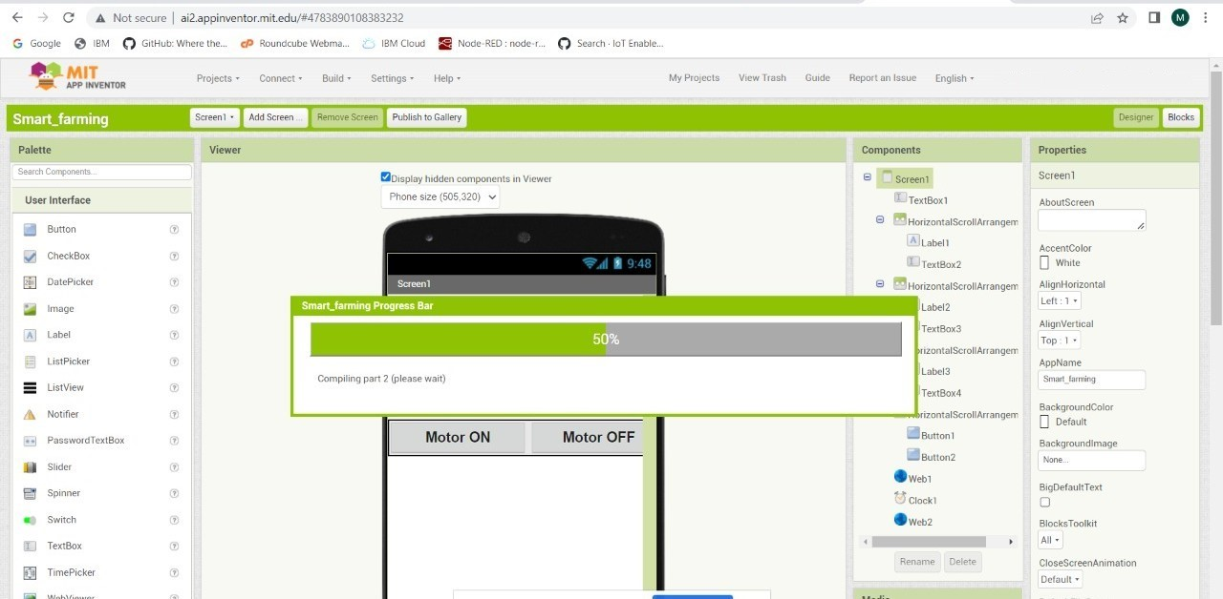

**Step 5:** Status or Output

